

**Group Name: ‘**Data Busters’

**Group Members:**

**NAME ID**

* Prakhar Nigam 2020A7PS0168H
* Kartikey Goel 2020A7PS2070H
* Aditya Dhanekula 2020A7PS0205H
* Ayush Khandelwal 2020A7PS2076H

**Project Title:**

**“ MindSpace ”**

**-*Workspace at your Will***

**Section 1: Project Description :**

The recent Covid Pandemic has greatly affected the way companies function. Companies have seen a shift in their mode of operation from physical offices to 'Work from Home.' Some offices have adopted this 'Work from Home' mode of operation permanently and require physical meetup only once a while to discuss their work and further proceedings. Some companies have also started to operate in a hybrid model. It gets hard for such companies to set up physical offices at prime locations because of the property and operational costs. We found a perfect solution to this problem.

We have developed a website that will serve the needs of such companies. Our website allows organizations to book physical workspaces for official meetings, work discussions, etc. We also provide users the flexibility to choose air-conditioned or non-air-conditioned rooms, the option to book food, and other facilities based on their requirements. Our website will work as an absolute solution for the problems of such organizations.

**Section 2: Constraints :**

**Data Level** Constraints:

1. Work locations are unique.

2. Workspaces are unique.

3. Slots which are already booked should not be available for others.

4. User cannot book without having sufficient money in the wallet.

5. Blocked users are not allowed to book a workspace.

6. Workspaces are associated to Locations ( Many to one )

7. Workspace managers are associated with Workspaces ( one to many )

8. A single customer can have multiple bookings.

9. A single booking can be associated with multiple facilities.

**Application Level** Constraints:

1. Workspace manager should not be able to view customer information.

2. Blocked users should not have access to the application.

3. Booking modification is not allowed beyond 2hrs of arrival time.

**GUI Level** Constraints:

* Application works on standard browsers.

**{MODULE WISE}**

Some of the constraints we will be dealing with are presented below:

* **LOGIN / REGISTRATION**
* Username - (follows a regular regex and has a character limit )
* Password - (follows a regular regex and must match ‘confirm password’ field)
* Name - (composite (first name, last name) and have corresponding character limits)
* DOB -(Regular Date-Time format)
* Mobile Number - (Standard format)
* **SLOT BOOKING**
* Workspace Size / Capacity - Fixed workspace sizes
* Location - Locations are managed by the admin.
* Services - Services provided are fixed and can only be modified by the admin.
* **TRANSACTION RELATED**
* Wallet credentials - All payments are done using the corresponding wallet.
* Customer Rating - Rating is an integer ranging from 1 to 5.

**Section 3: Functionality supported :**

**Admin** Functionalities:

* Adding a location.
* Adding workspaces to a particular location.
* Edit / Delete and manage the details of a workspace.
* View all the bookings in a particular location.
* Add / Remove services(can include additional amenities like projector, whiteboard, etc.) provided in a workspace.
* Can manage the price of a slot.
* View rating and feedback.

**User** Functionalities:

* Book a slot by specifying the location, check-in-time, check-out-time, and the facilities required.
* Select additional facilities required, for example: Whiteboard, projector, extra seats, etc.,
* Cancel / Modify booking. Corresponding refund rates apply.
* Make a payment: The user has a wallet where they can load money, and any transactions made from thereon will be deducted from their corresponding wallet.
* Provide Feedback

**Workspace Manager** Functionalities:

* Acts as a staff member, and can monitor the workspace.
* Will have his own login credentials and dashboard.
* Can see all current bookings and services details.
* He himself can’t book a workspace.
* will provide the services and additional facilites asked by the user based on availability at a reasonable price.

**Section 4: GUI Layout/ Navigation and the purpose :**

1. Application Homepage (To know more about workspace and contact the owners)
2. User Login/Sign-up Page( Common to both admin and user)
3. Admin:

* Admin Homepage: The Homepage or landing page contains the general information and statistics of the system.
* Menu Options:
* Facilities: Can manage (add/edit/delete/block) the facilities available in a workspace.
* Locations: Can manage (add/edit/delete) the locations present.
* Workspaces: Can add a workspace in a particular location and can manage that particular workspace. The price of a workspace is determined on an hourly basis and is set by the admin.
* Bookings: Can view the current bookings in a particular location.

1. User:

* User Homepage
* Menu Options:
* Slot Booking: Option to enter details regarding the booking and to book a particular slot. The price is set on an hourly basis, and the total amount is displayed to the user before he confirms the booking.
* Wallet Transactions: View wallet balance with an option to add money to the wallet.
* Booking History: View past, current, and future bookings with an option to modify or cancel future bookings.
* Feedback: Option to provide valuable feedback which will be reflected to the admin.

1. Workspace Manager:

* Worker Dashboard
* Menu Options:
* View current bookings status
* Additional facilities
* Services available

**Section 5: Technologies used :**

* We will be using JAVA-MySQL as a Programming language and RDBMS.
* Other languages we will be using are: HTML, CSS, and Javascript for the GUI Portion.
* We will be using MVC(Model View Controller) architecture to design our project.

===============================================

**ER DIAGRAM:**

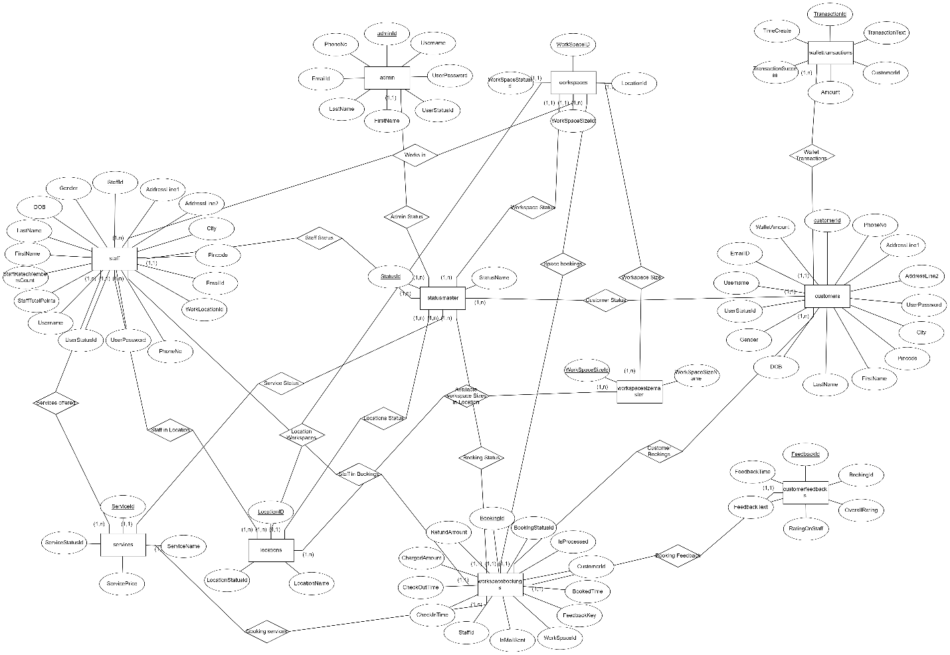

**RELATIONAL MODEL:**

**1. Statusmaster**

(StatusId, StatusName)

**FD: A->B**

**CK: A**

**2. WorkSpaceSizeMaster**

(WorkSpaceSizeId, WorkSpaceSizeName)

**FD:** A->B

CK: A

**3. Locations**

(LocationID, LocationName, LocationStatusID)

**FD:** A->B,C

**CK: A**

LocationStatusID is foreign key referencing StatusId of Statusmaster.

**4. Locationworkspacecounts**

(LocationID, WorkSpaceSizeId, AvailableCount)

**FD:** AB->C

**CK: AB**

LocationID referes to Locations and WorkSpaceSizeId refers to Workspacesizemaster.

**5. Workspaces**

(WorkSpaceID, LocationId,WorkSpaceSizeId, WorkSpaceStatusId)

**FD:** A->B,C,D

**CK: A**

LocationID refers to Locations. WorkSpaceStatusId refers to Statusmaster. WorkSpaceSizeId refers to Workspacesizemaster.

**6. Workspacestaff**

(WorkSpaceID, StaffId)

**FD:** A->B

**CK: A**

WorkspaceID refers to Workspaces. StaffId refers to Staff.

**7. Services**

(ServiceID, ServiceName, ServicePrice, ServiceStatusID)

**FD:** A->B,C,D

**CK: A**

ServiceStatusID refers to StatusId of Statusmaster.

**8. Admin**

(adminId, Username, UserPassword, UserStatusId, FirstName, LastName, EmailID, PhoneNo)

**FD:**

A->B,C,D,E,F,G,H

B->A,C,D,E,F,G,H

G->A,B,C,D,E,F,H

**CK: A,B,G**

adminID refers to StatusId of Statusmaster.

**9. Customers**

(customerId, Username, UserPassword, UserStatusId, FirstName, LastName, DOB, Gender, EmailID, PhoneNo, AddressLine1, AddressLine2, City, Pincode, WalletAmount)

**FD:**

A->B,C,D,E,F,G,H,I,J,K,L,M,N,O

B->A,C,D,E,F,G,H,I,J,K,L,M,N,O

I->A,B,C,D,E,F,G,H,J,K,L,M,N,O

**CK: A,B,I**

CustomerId refers to Statusmaster.

**10. Staff**

(StaffId, Username, UserPassword, UserStatusId, FirstName, LastName, DOB, Gender, AddressLine1, AddressLine2, City, Pincode, EmailID, WorkLocationId, PhoneNo, StaffTotalPoints, StaffRatedMembersCount)

**FD:**

A->B,C,D,E,F,G,H,I,J,K,L,M,N,O,P,Q

B-> A,C,D,E,F,G,H,I,J,K,L,M,N,O,P,Q

M-> A,B,C,D,E,F,G,H,I,J,K,L,N,O,P,Q

**CK: A,B,M**

StaffId refers to Statusmaster. WorkLocationID refers to LocationId of Locations table.

**11. Staffservices**

(StaffID, ServiceID)

**FD:** AB->AB

**CK: AB**

StaffID refers to Staff table. ServiceID refers to Services table.

**12. Workspacebookings**

(BookingId, CustomerId, WorkSpaceId, StaffId, CheckinTime, CheckoutTime, ChargedAmount, RefundAmount, BookingstatusId, IsProcessed, IsMailSent, BookedTime, FeedbackKey)

**FD:** A->B,C,D,E,F,G,H,I,J,K,L,M

**CK: A**

CustomerId refers to Customers table. WorkspaceId refers to Workspaces table. StaffId refers to Staff table. BookingStatusID refers to Statusmaster.

**13. Bookingservices**

( BookingId, ServiceID, Quantity, ServicePrice)

**FD:** AB->D,E

**CK: AB**

BookingID refers to Workspacebookings. ServiceID refers to Services.

**14. Wallettransactions**

(TransactionId, TransactionText, CustomerId, Amount, TransactionSuccess)

**FD:** A->B,C,D,E

**CK: A**

CustomerId refers to Customers table.

**15. Customerfeedbacks**

(FeedbackId, BookingId, OverallRating, RatingOnStaff, FeedbackText, FeedbackTime)

**FD:** A->B,C,D,E,F

**CK: A**

BookingId refers to Workspacebookings.

**SCREENSHOTS:**

**Admin:**

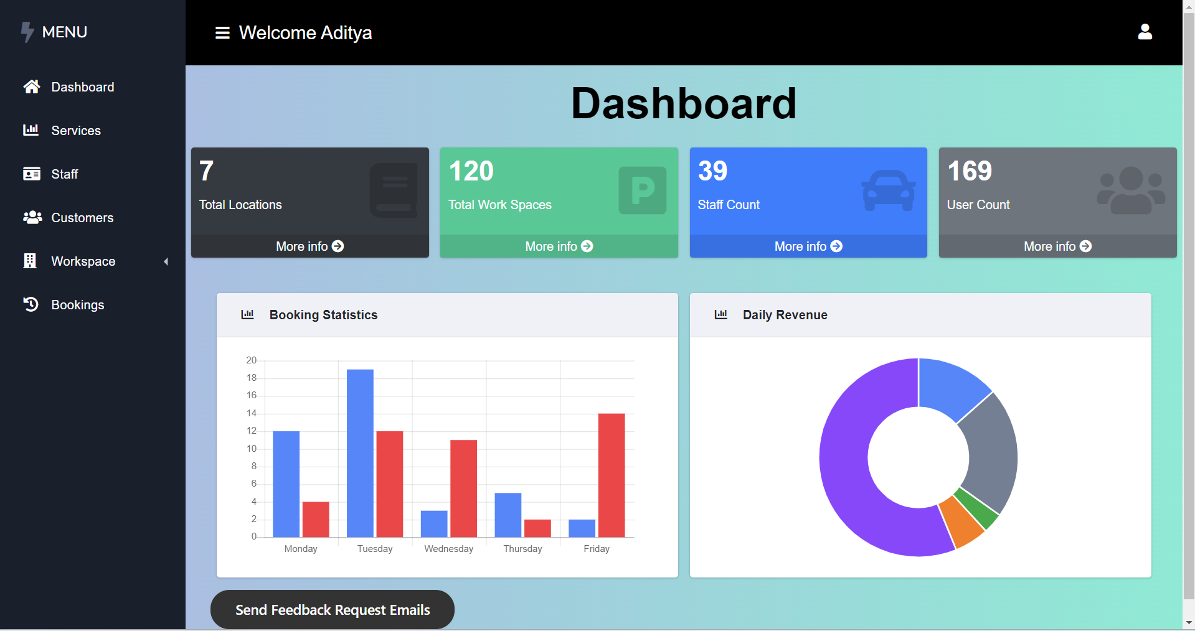

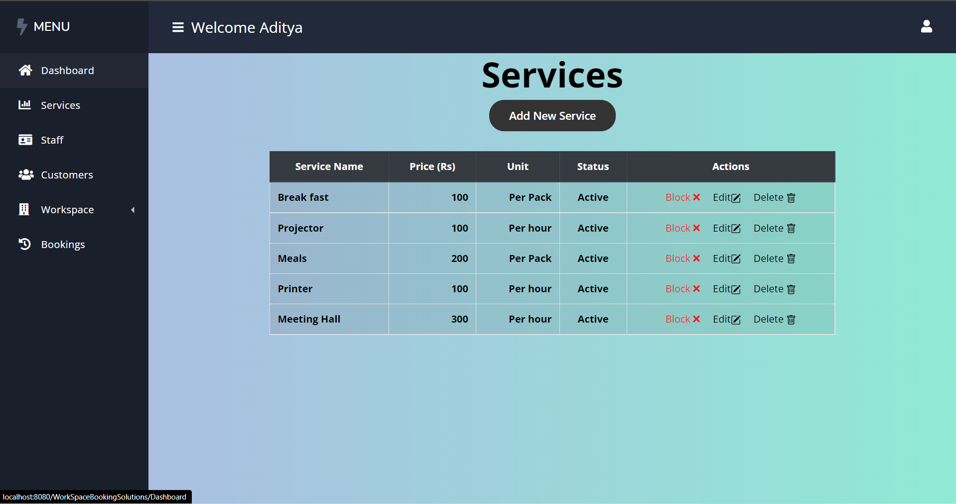

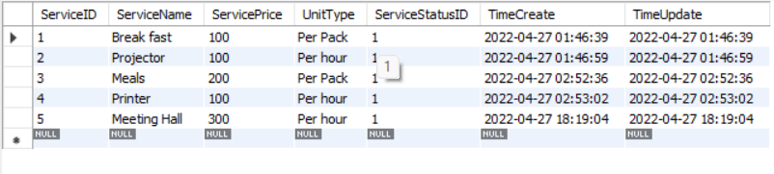

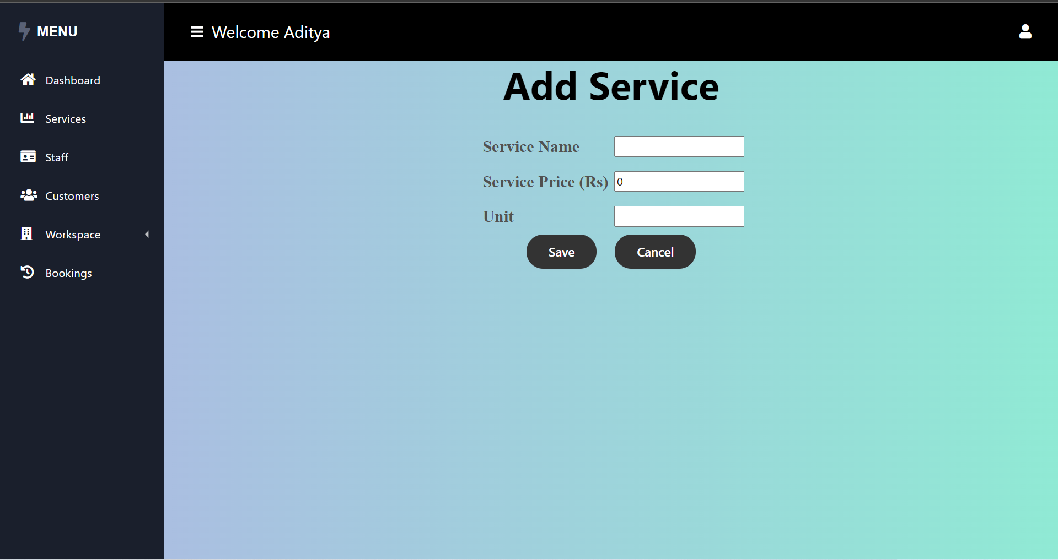

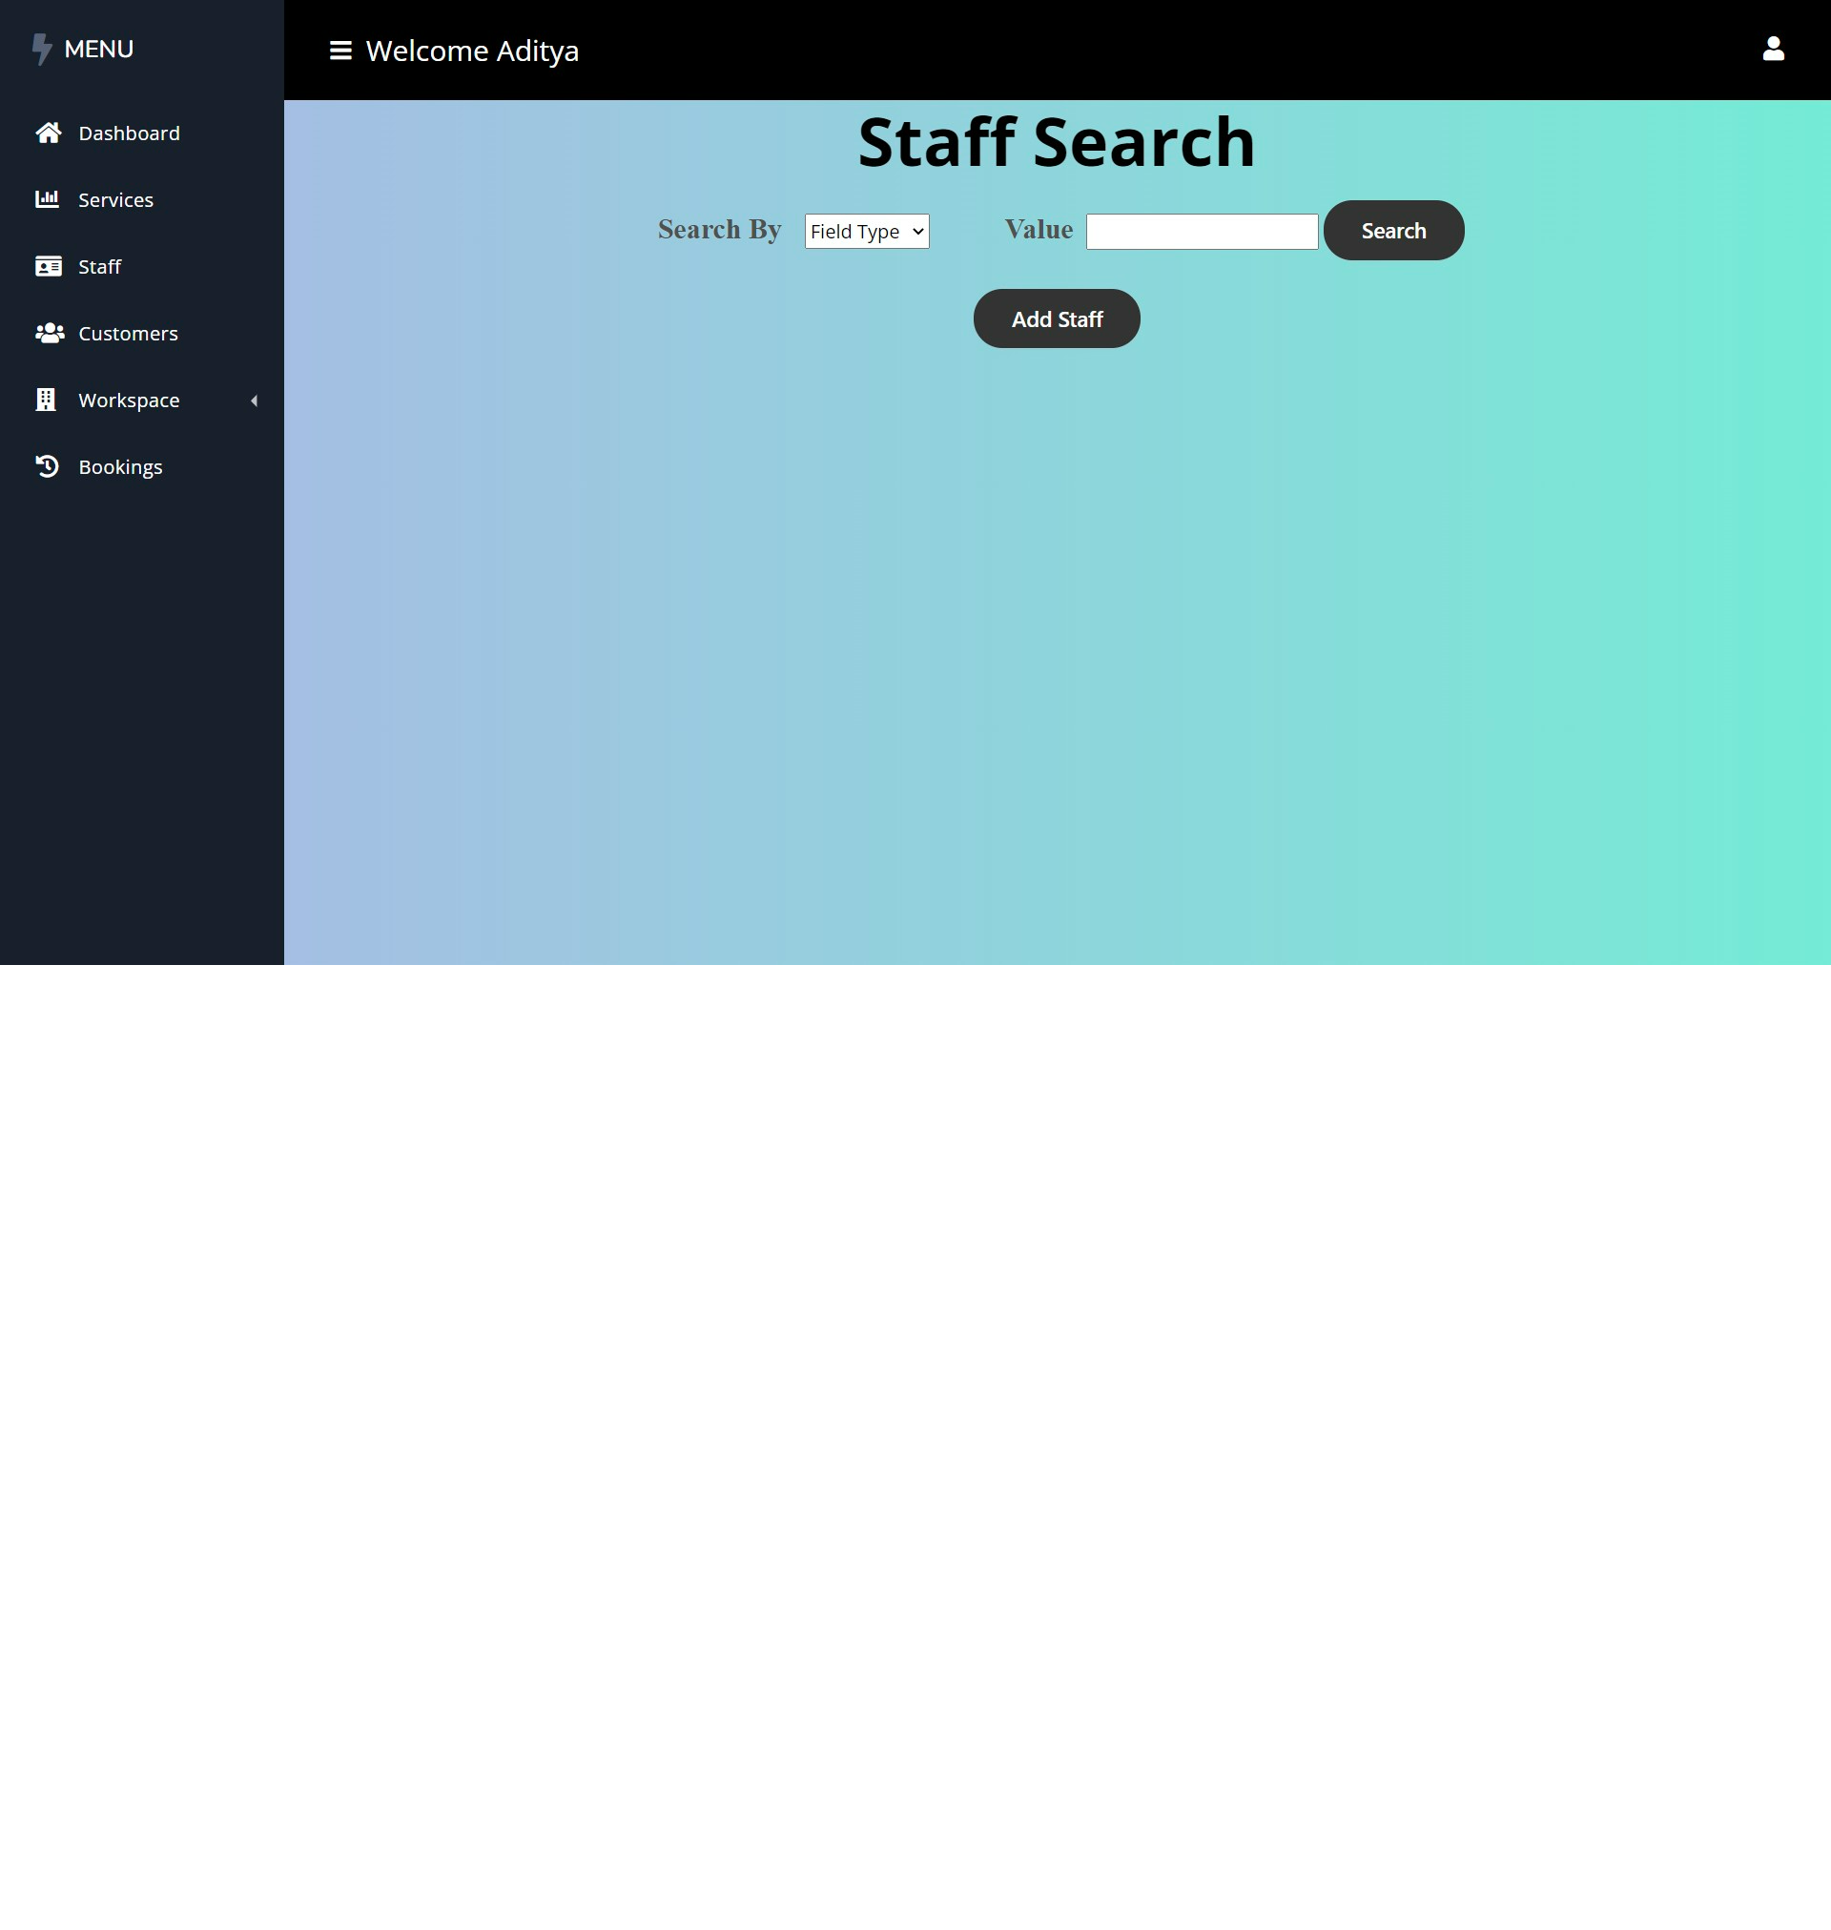

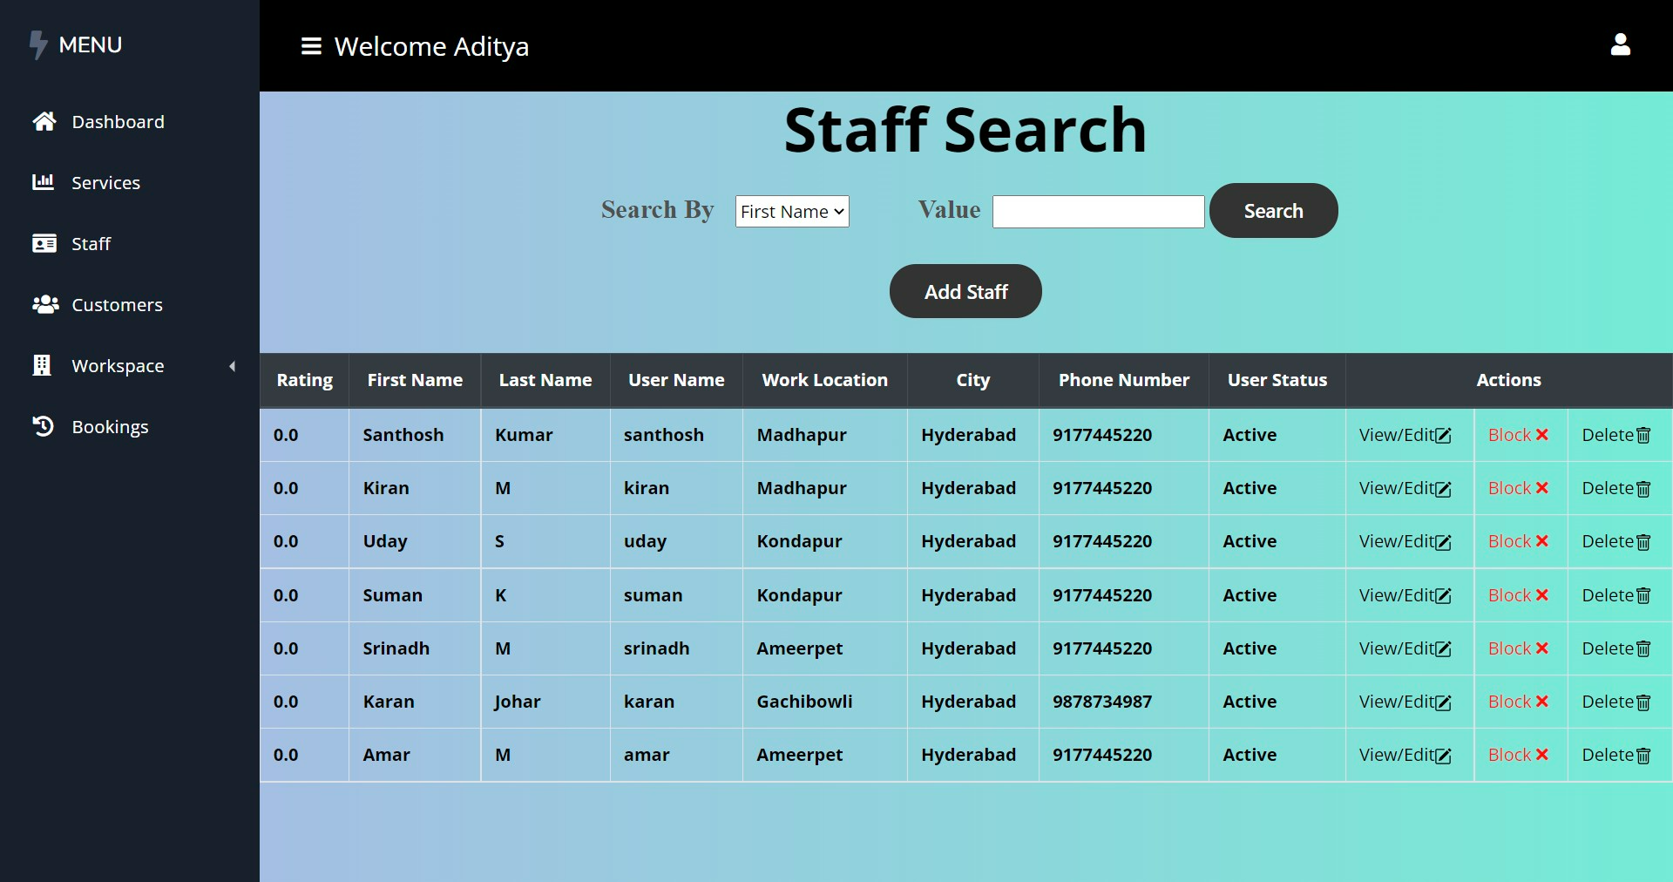

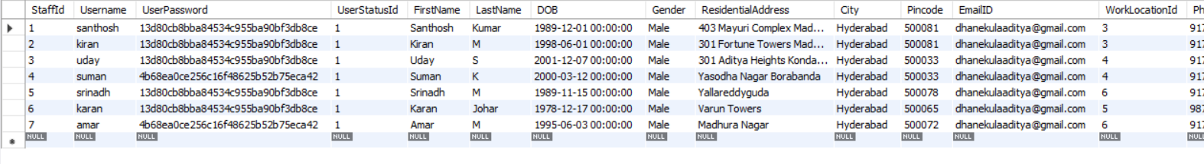

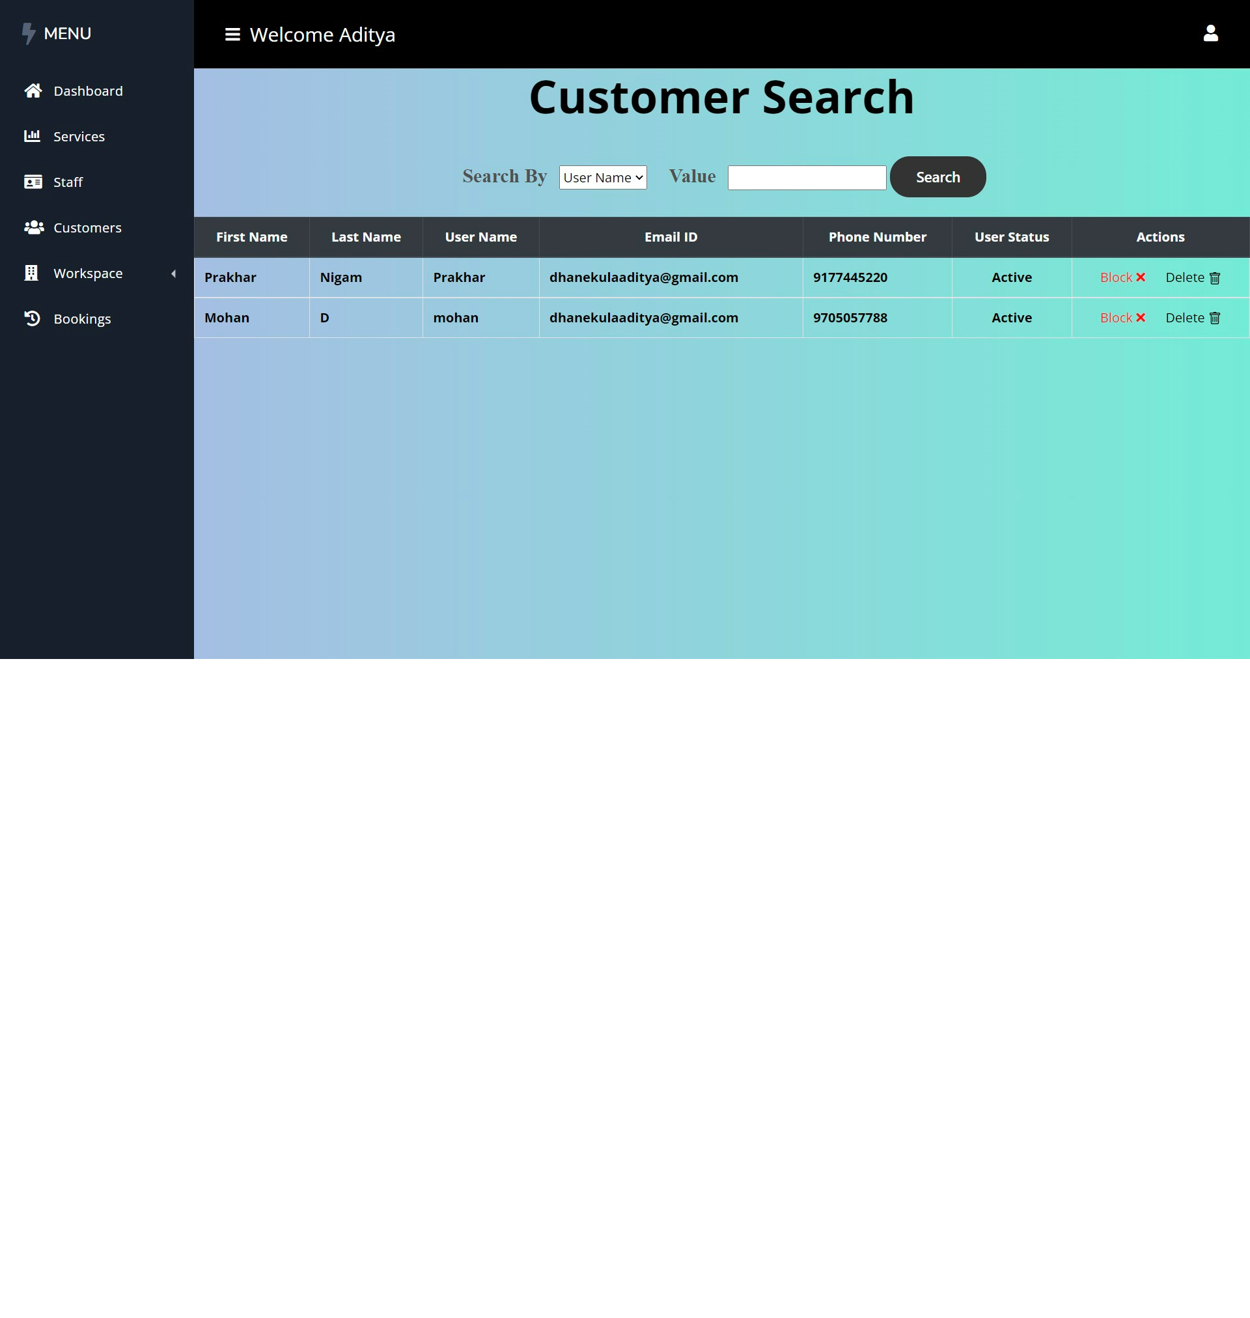



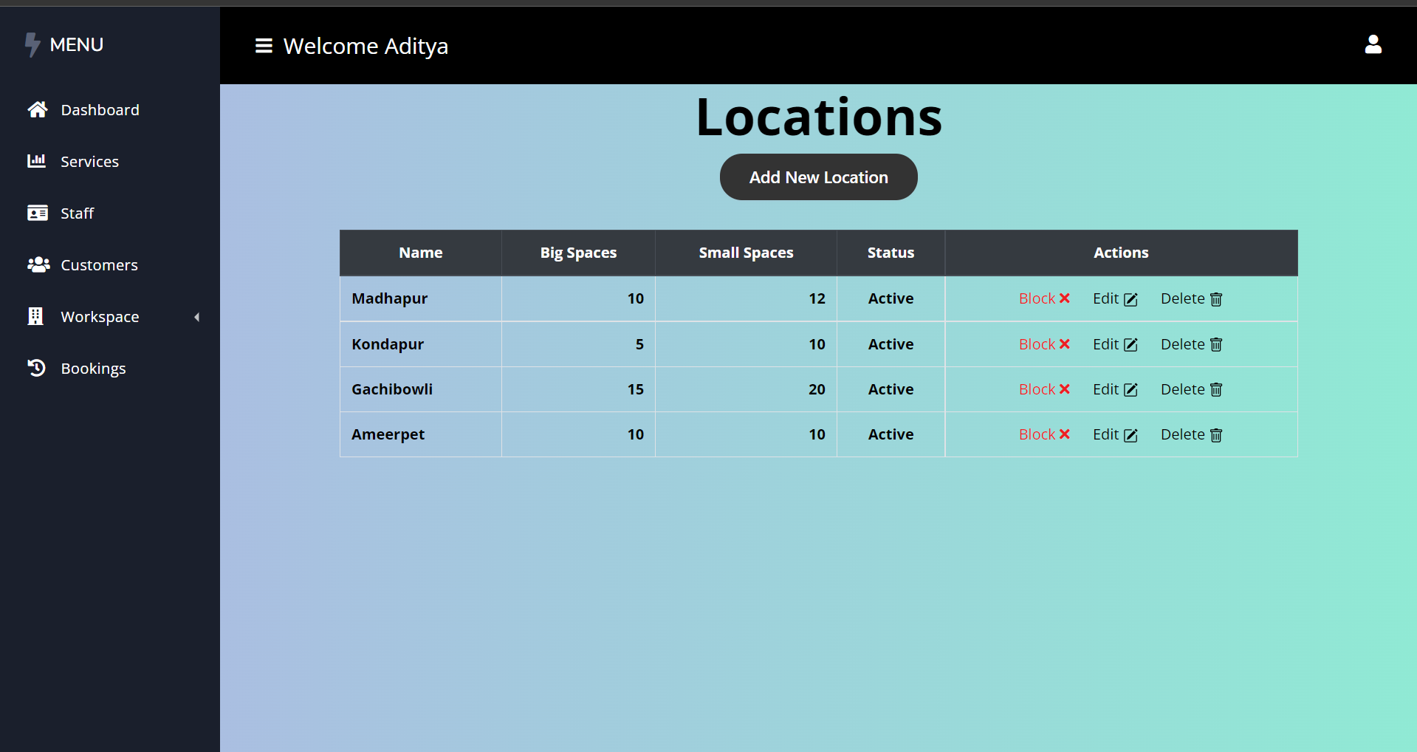

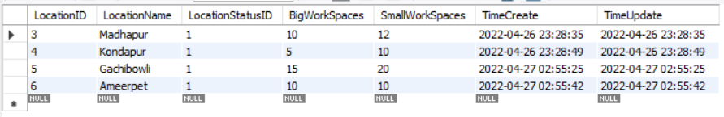

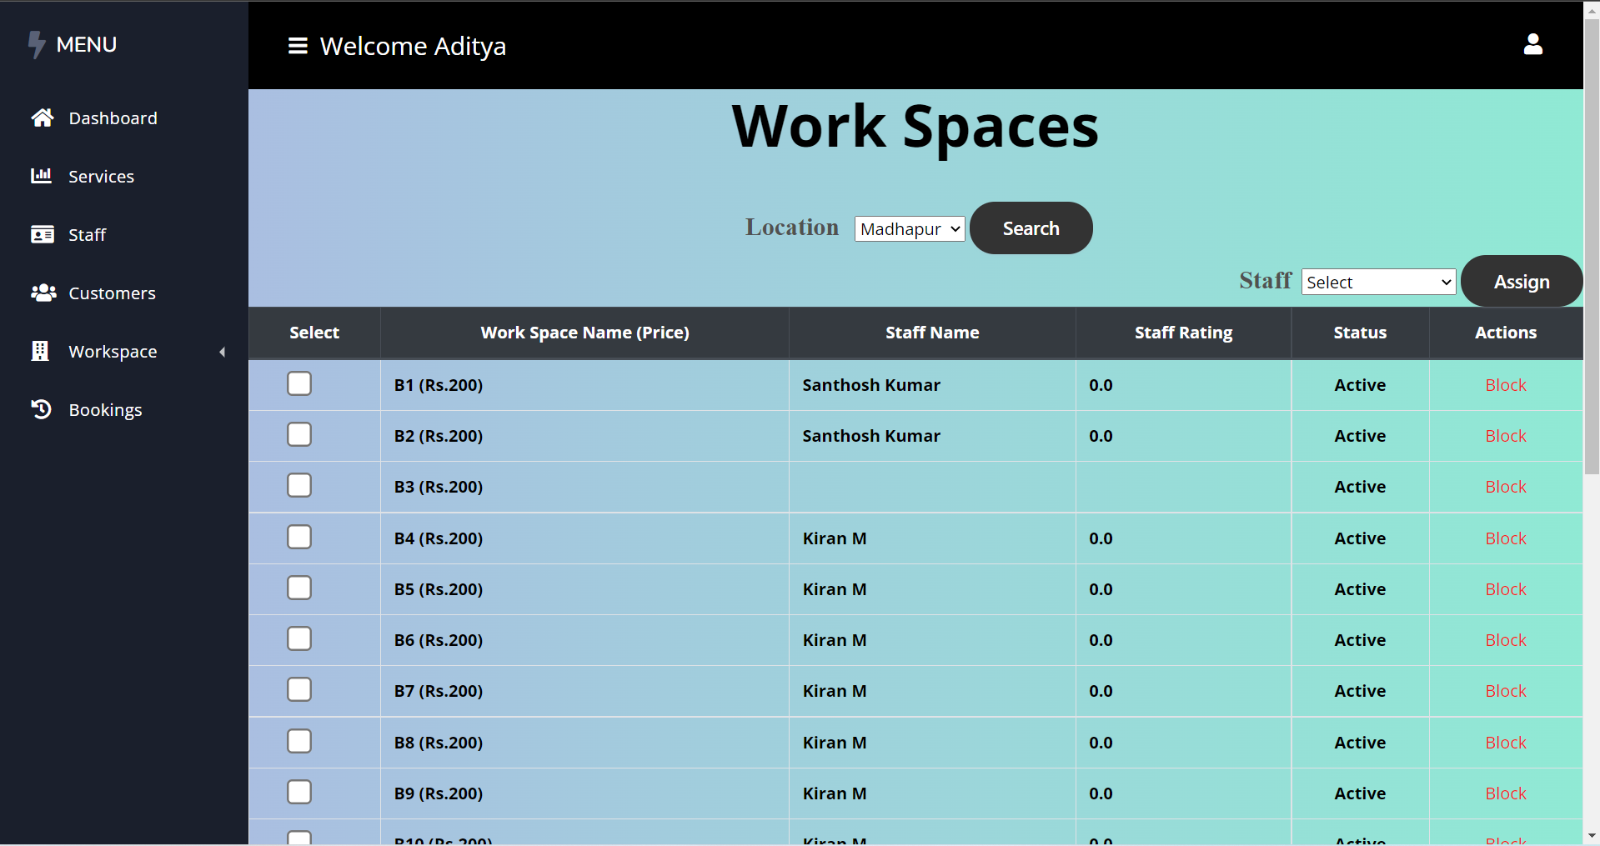

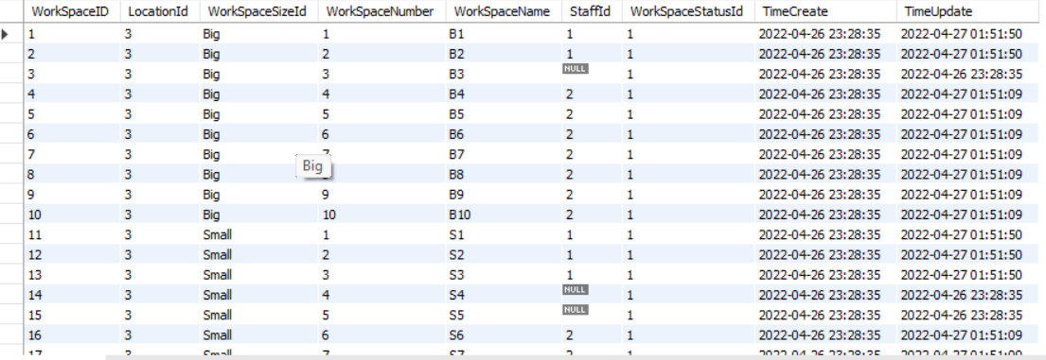

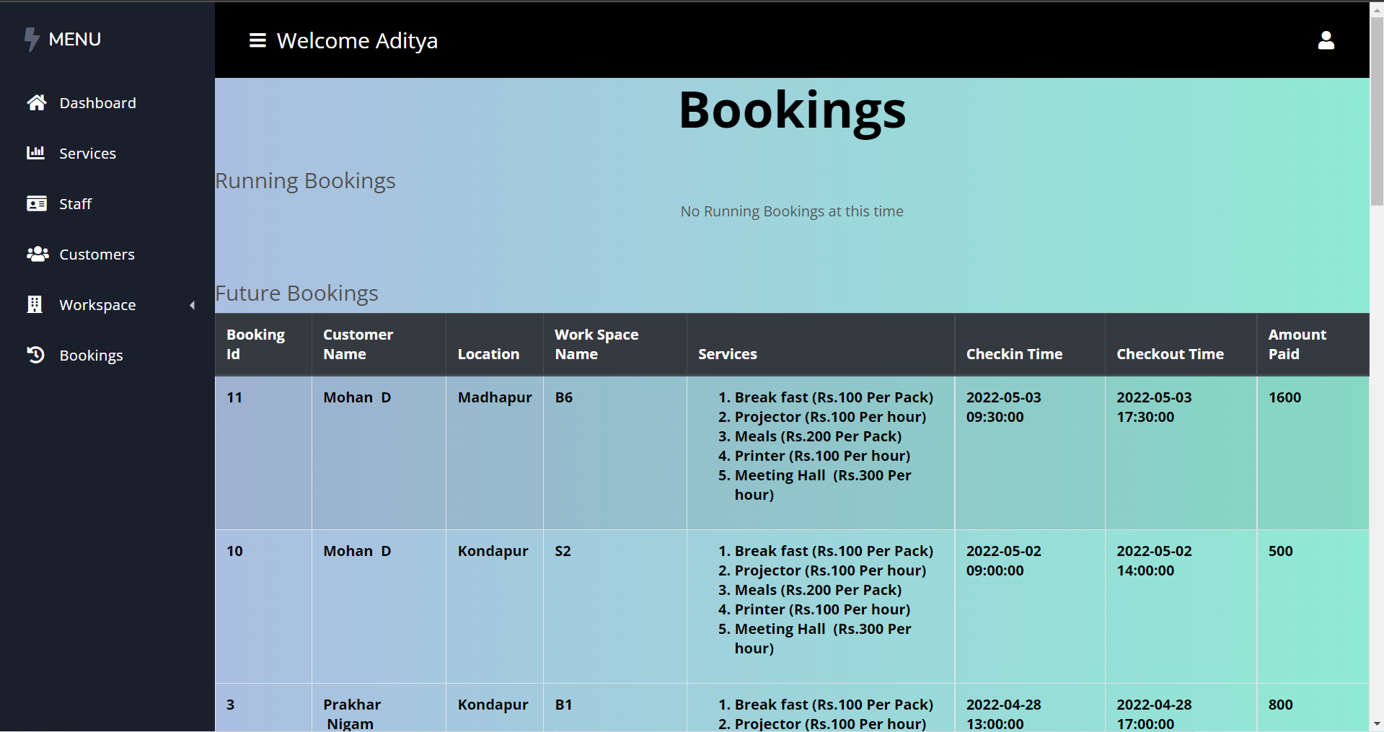

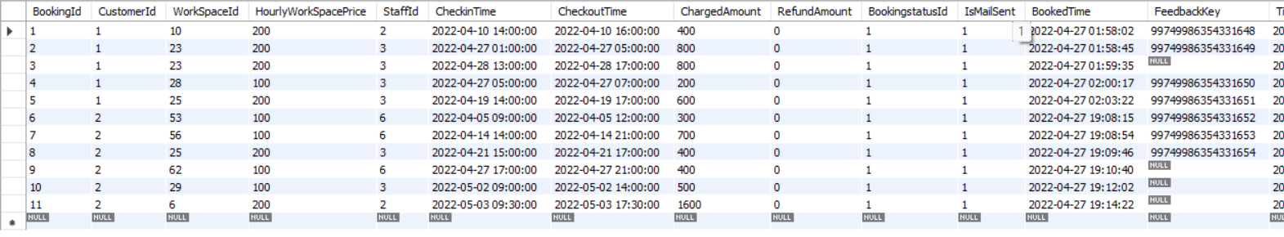

**STAFF:**

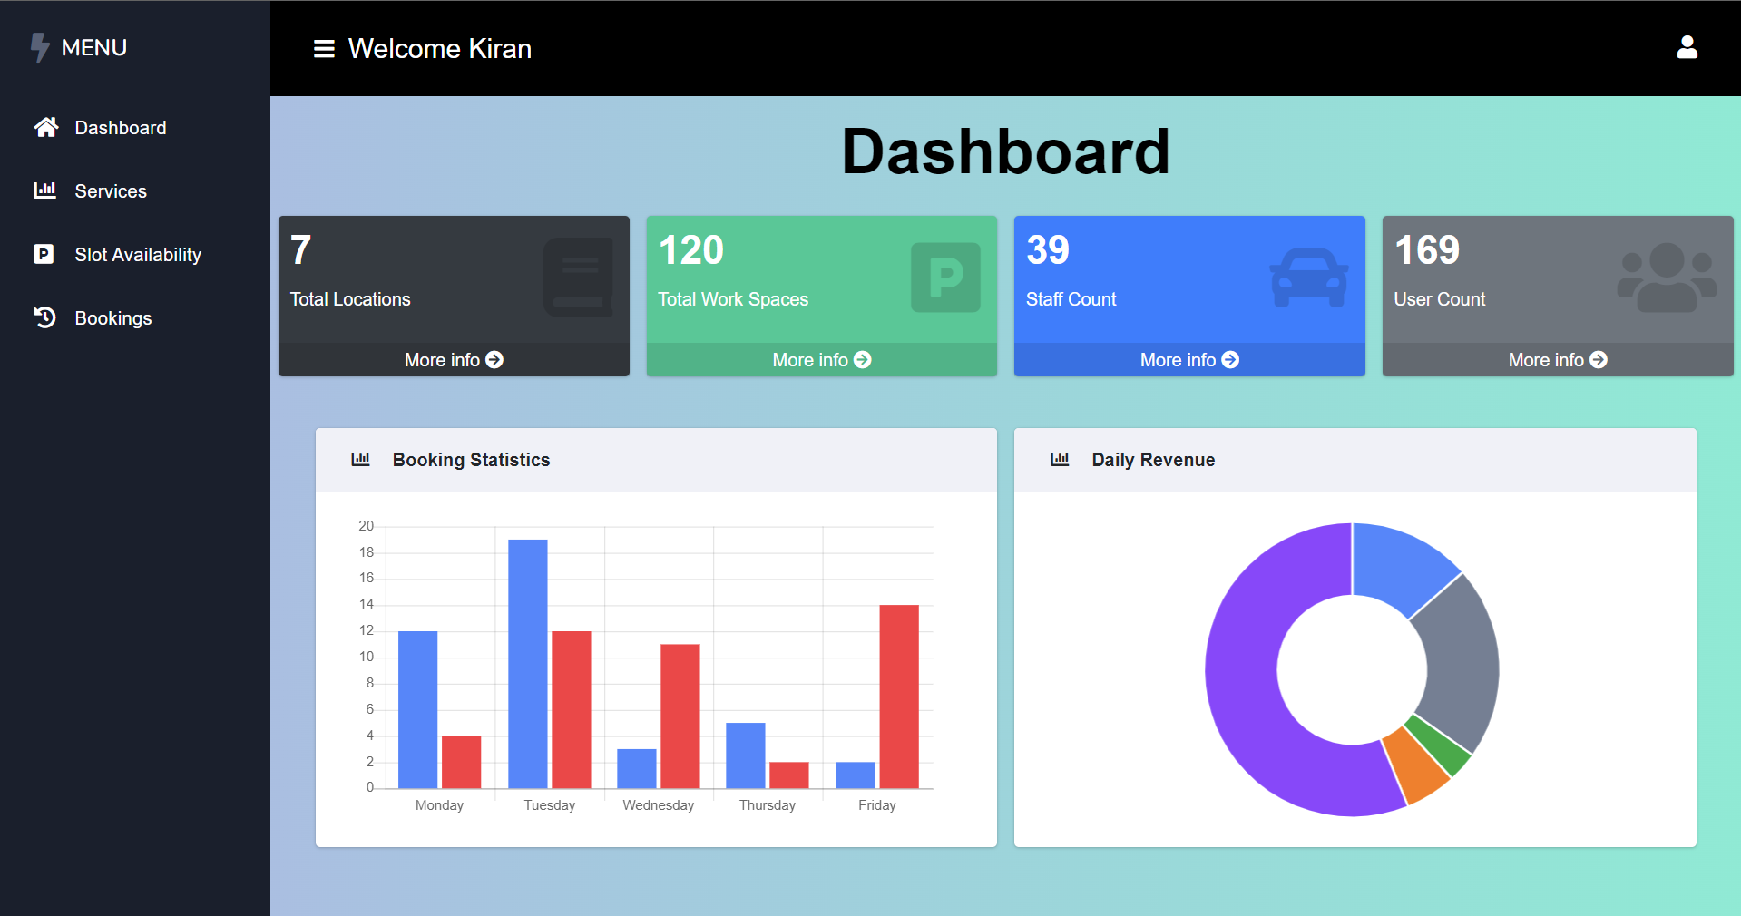

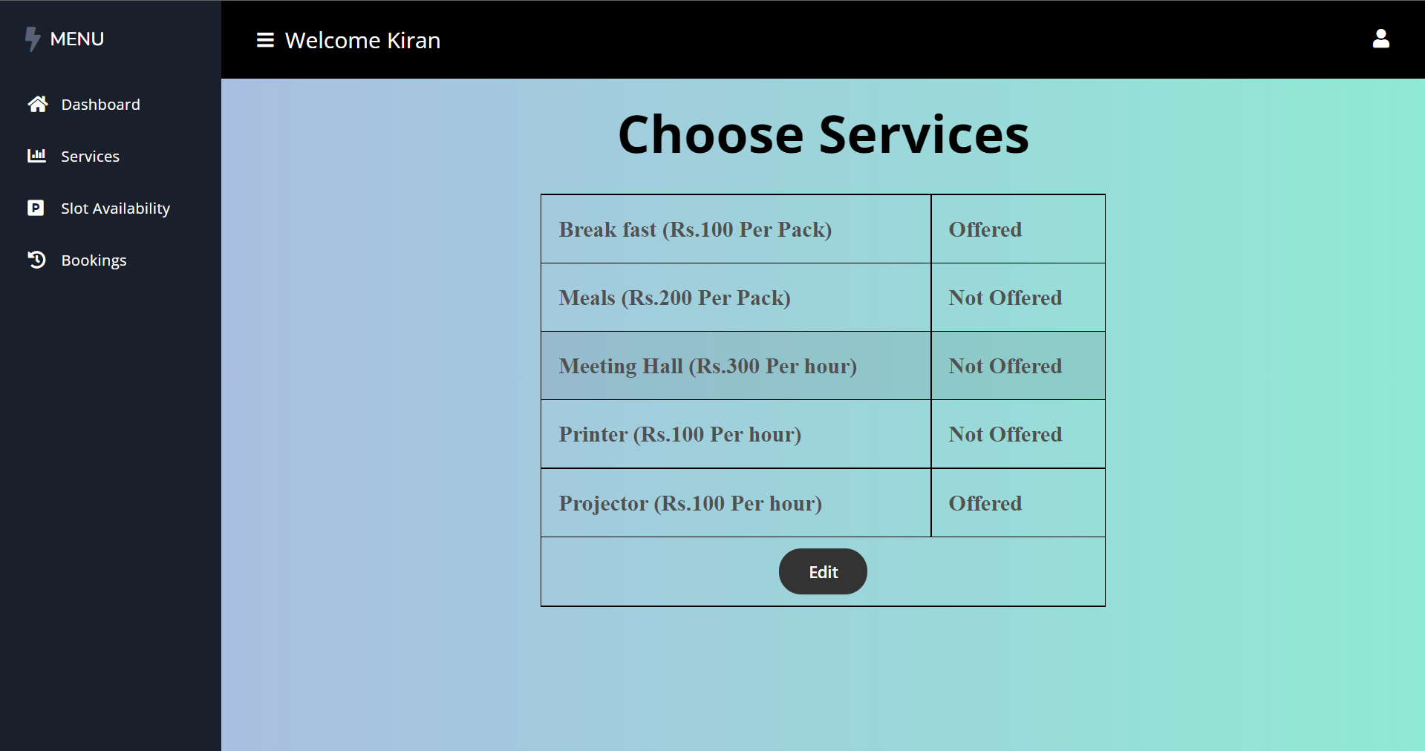

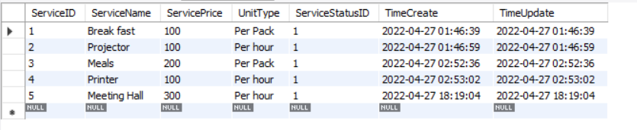

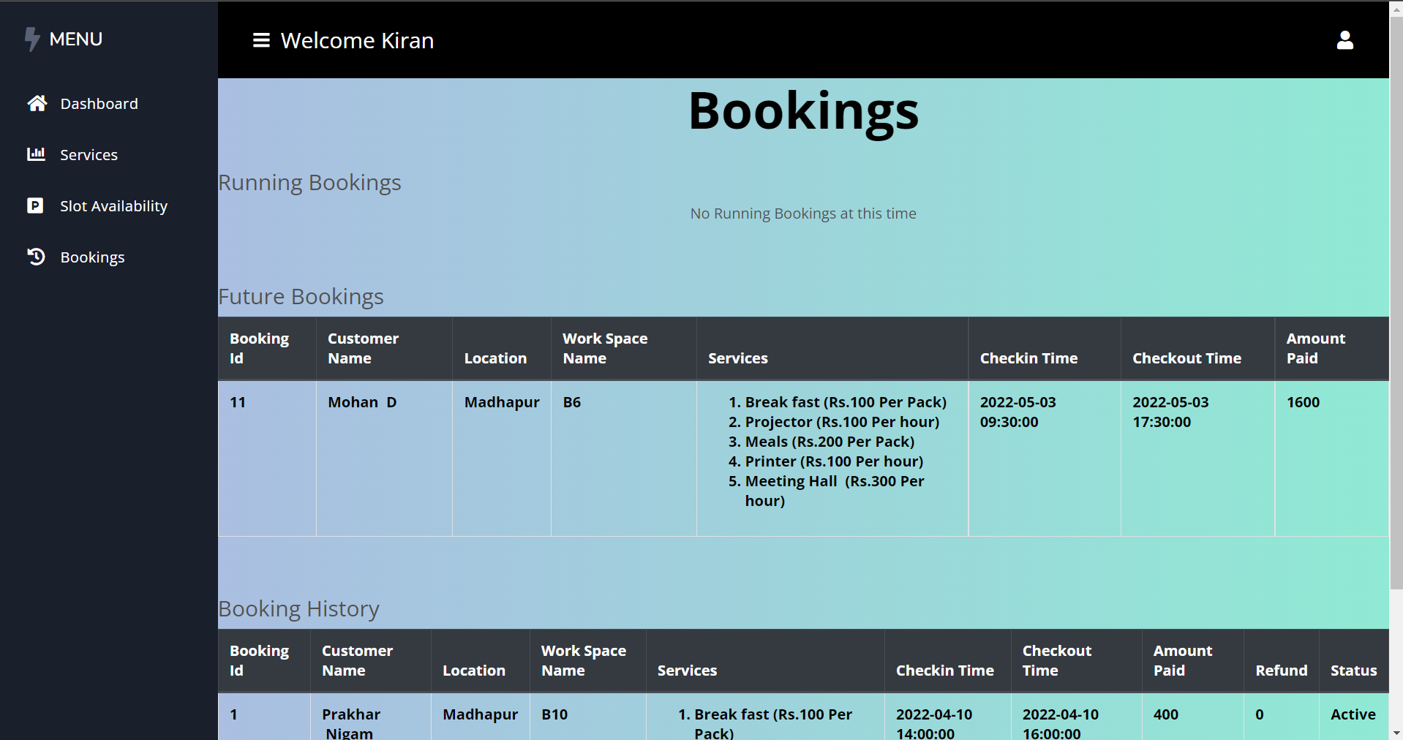

**CUSTOMER:**

